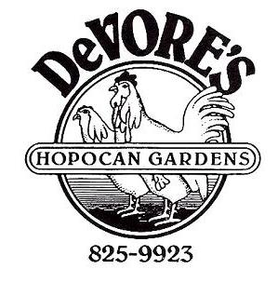
4/14/2023
Catering
& Buffets

$16.95* $18.95* $20.95*
Barberton Chicken Barberton Chicken Barberton Chicken
2 Vegetables 1 Additional Meat 2 Additional Meats
1 Potato 3 Vegetables 3 Vegetables
2 Potatoes 2 Potatoes

($1.25 per person for each additional potato)
($1.25 per person for each additional vegetable)
*All dinners include paper plates, napkins, utensils,
bread & butter, coffee, tax and tip
Children’s meals 10 years and under 75% of price

Meats Vegetables
Legendary Barberton Chicken Original Recipe Hot Sauce
Hungarian Pigs-in-a-Blanket Tangy Cole Slaw
(Cabbage Rolls) Fancy Apple Sauce
Glazed Ham Creamy Green Beans
Beef Tips w/Gravy Whole Kernel Corn
Lasagna Twists Mixed Vegetables
Seafood Pasta Relish Tray
Chicken Tenders

Potatoes
Macaroni Salad Scalloped Potatoes
Creamy Mushroom Noodles Mashed Potatoes & Gravy
Parsley Potatoes Chunky Potato Salad
Cheesy Hash browns

If a sit-down dinner is more to your liking.
DeVore’s Hopocan Gardens Banquet Prices
are available upon request.
All prices include the tax, tip and beverages (coffee or soft drink).
Beer and wine are also available.
Available seating for up to 90 people.

Contact Sherry Winston or Brian Canale 330-825-9923
OR e-mail request to hoppy283@att.net

